OTG Voice Trainer
Functional Specification
Sam Von Ehren
Last Updated: Tuesday, August 24, 2010

Overview:
This is a specification for an iPhone app, OTG(on the go) Voice Trainer, which aids aspiring and professional singers practice vocal technique in places they’d have trouble doing so. The app contains several sub-apps that can be shipped as separate apps, or packaged together at a discount price.
This spec is not complete and is mainly a basic breakdown of ideas and features to be implemented.

Meet the Sub-Apps:
The global app will have four different sub apps: A warm up app, an interval training app, a sight singing training app, and a game where the avatar is controlled through pitch. Each app will be covered in more detail later.

Scenarios:
Scenario 1:
Jon is a beginning voice student who takes voice lessons in the early afternoon in Boston. He lives in a suburb out of Boston though and needs to take a train to get to his voice lessons. Since there he doesn’t travel during rush hour, the train is usually pretty empty. Jon usually sings some scales to himself to pass the time, but on account of Jon’s lack of experience, his scales are usually pretty out of tune. When Jon purchases the OTG Voice Trainer, he can see how well his tuning is for his warm ups using the Warm Up feature and improves his technique much more rapidly as a result.
Scenario 2:
Mindy is an amateur singer with no formal training who just enjoys singing anything. Mindy often rides the subway to work, where she talks to people using her Bluetooth headset. On a given day Mindy has no one to talk to and is bored, so she pulls up the Sight Singing game on OTG Voice Trainer. Using her voice as a controller, she passes the time while strengthening her vocal cords and her sight singing.
Scenario 3:
Larry is a college student intent on becoming a strong singer. His voice teacher tells him that he needs to strengthen his intervals and sight singing. Larry also lives across campus from the music building, and hates to walk all the way there every night to practice these things specifically. With the OTG Voice Trainer’s interval training and sight singing trainer, he can practice easily from his room.

Long Term Development Plan:
The scope of this project is very ambitious for the two man shop that we are. Rather than tackling the entire project all at once, the four submodules of the project will be built upon one another, giving us new tools for the following parts of the project. The first sub-app should be the interval trainer. Similar apps on the app store cost a minimum of $5. Given our two man shop, we should be able to develop similar software and then package it at an under cutting price of $3. This will give us the ability to verify pitch. After developing the interval trainer, we’ll move on to the warm up app. With development of the warm up app, we will develop the ability to play notes, display them, and verify the accuracy of the singer’s pitch. This sub app will give us reading in of note patterns, playing of note patterns, and verifying note patterns in time. Finally we will move to the sight singing app, which will involve randomized musical lines that are played and verified immediately. After that, the sight singing game should be relatively easy to code.

Interval Trainer:
The interval training portion of the app is a simple, repeating guessing game. The app presents the user with a root note, and then asks them to sing the interval shown. The interval trainer will have multiple difficulty levels, and will keep track of scores.

Interval Trainer Screen by Screen:
Interval Training Difficulty Select
The Interval Training Difficulty Select Screen will have three difficulty levels. Difficulty Levels will just determine the type of intervals the user will be tested on.
Interval Training Screen
When the interval Training Screen pops up, it will first ask the user to sing a comfortable low note. This will be the “base” frequency, all intervals will be no more than an octave above this frequency, and not at all below it. After the initial frequency, the app will have an interval displayed and play the root note the singer needs to find the interval from. There will be a “Replay” button and a “Give Up” button as well, for newbie users. When the “Give Up” button is pushed, it plays the interval and prints the correct note. If the user sings a note that is not within 5Hz or so (depending on the difficulty level), the screen flashes red and then runs the same function as the “Give Up” button, but with a small text box showing how far off they were. If they sing the right note within tolerance, the screen will flash green and proceed to the next note.
For example: Bill is a singer who knows his fourths like nobody’s business, for some reason though, he can’t sing a fifth to save his life, and doesn’t even know what a minor third is. Bill starts up the Interval Trainer on Easy. The screen prints “G” and plays a G and tells him to sing a fourth above it. Bill sings a C no problem, the screen flashes Green, prints a C, and then plays an A flat and tells him to sing a minor third above it. Bill has no idea how to sing one, so he hits “Give Up”. OTG plays a B natural and prints it. The app then tells bill to sing a fifth above C and plays a C. Bill thinks awhile, about the interval. He sort of forgets the note and hits “Replay” to hear it again. He guesses the note, but is a little too flat, and gets a red screen. The app then tells him the correct note was a “G” and moves on to the next exercise.

Interval Trainer Architecture:
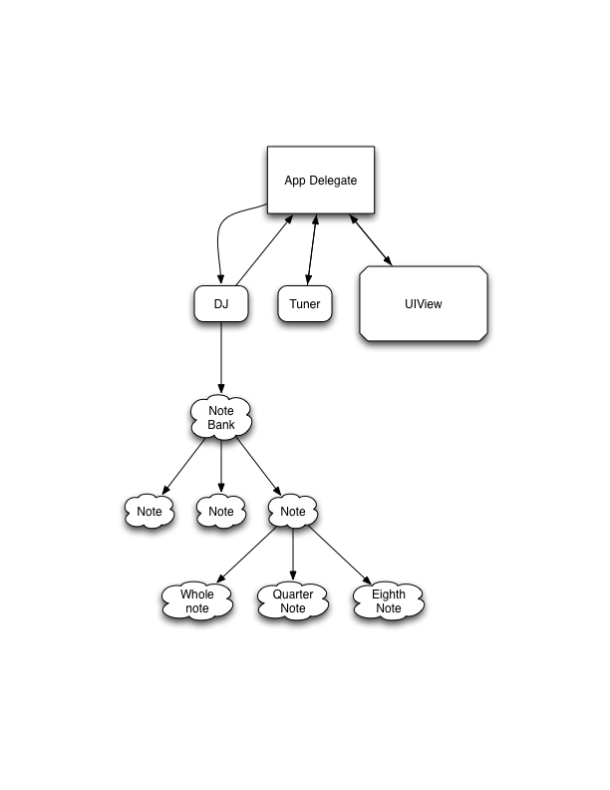
The interval Trainer will be comprised of 4 main components: The DJ, responsible for playing notes sent to it, The Tuner, who verifies if the note sung is correct, the delegate, which runs administrative duties like picking the notes, intervals, and keeping track of score, and the View Controller, which interfaces with the user, and displays notes based on what the delegate sends it. On top of this will be an upgraded note class, which will now include duration.

Upgraded Note Class:
We will reuse the note class from our Musical Frequency Look UP Kit app, with the addition of SystemSoundIDs linking to samples of the note in each of durations: whole, half, quarter, eighth, sixteenth. The note class will also contain a function playNote:NSString* that will take in a string with the note duration, and call another function in the note class to play that note. The note class will also need a special init function to ensure loading of all the URLs. In summary the note class will look like:
Public:
Double frequency
NSString * note
-(void) playNote:(NSString *) theNote
private:
(void)playWhole
(void)playHalf
(void)playQuarter
(void)playEighth
(void)playSixteenth

DJ:
The DJ part of the app will be responsible for containing and playing notes sent to it. The DJ will contain an array of notes between F2 and C6 (The lowest note in a bass’s range and the highest in a soprano’s). The DJ will be handed a string with a note and a duration, in the format @”Cb6Q”, where Q stands for quarter note. The DJ will then search through his array (starting at the lowest note input by the user) until it finds the proper note, then will send the note a message with the string he used to find it I would like to mention here that I don’t think this particular way of doing things is optimal for this app, but I’d rather practice using the note class this way because I think it will helpful down the line. The DJ will contain the following members and functions and include Note.h:
Public:
(void)playNote:playMe // conducts the linear search for the note playMe
(void) setBase:baseNote // sets the base member of the array for the DJ to start searching from
private:
NSArray *NoteBank // Contains all the notes
NSIndexSet viableNotes

Tuner:
The tuner will be a simple, reusable class. The DJ will be handed a sound file and will use Fast Fourier Transformations to figure out a pitch. I’m leaving this part mostly blank for logan to fill in. But I think the Tuner should work like this: The delegate will send the tuner the note that is the right answer, the tuner will listen to the frequency, and if the sung frequency is within tolerance, it will return a positive answer. If the singer is flat or sharp, the tuner should return a message signifying which they are.

Delegate
The delegate will be in charge of managing the notes and making sure the other parts of the sub-app are informed of what is going on. The main work flow of the delegate app is in the following diagram: 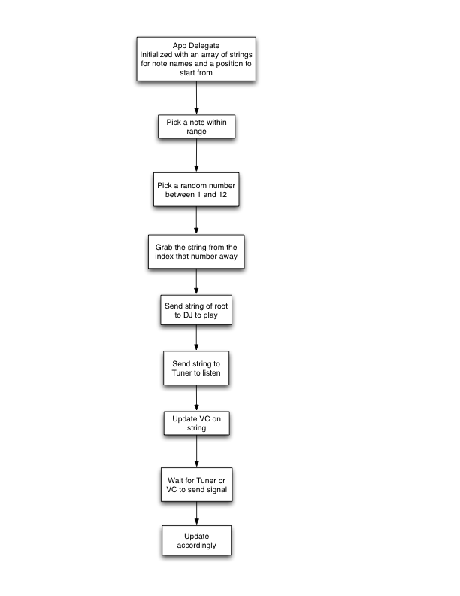
The app delegate will have an enumerated type for the intervals:
enum interval {uni, minSecond, majSecond, minThird, majThird, perfectFourth, triTone, perfectFifth, minSixth, majSixth, minSeventh, majSeventh, octave};
intervals will be sent to the View Controller to update its display and will be utilized to grab the string for the note to be played. The delegate will have the following members:
NSNumber iCurBase // The index of the lowest note we’re allowed to use. Will not change
NSString sCurRoot // the name of the note to be played
NSString sCurTarget // the name of the note to be sung by the user
Init()
getDifficulty

OTG Voice Trainer Ideal Flowchart:
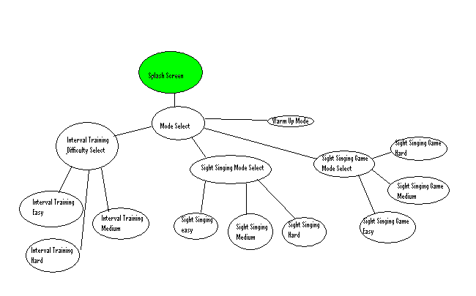

OTG Voice Trainer Screen by Screen Breakdown:
Splash Screen
The splash screen will simply display the name of the App, the developer names, copyright info etc. Nothing fancy, and very likely to be removed from the final spec.

Mode Select
The Mode Select Screen will have a text box at the top that reads “Mode Select” and have four buttons underneath it, each linking to the associated sub-app. Underneath all of these will be a 4 radio button equivalents that indicate voice part. This setting should be saved between boot ups of OTG Voice Trainer, and will be carried through to the different modes to determine clef and range.

